# INTRODUCTION

Covid-19 is one of the most noteworthy wide-spreading issues all over the world. In this widespread time, the world wellbeing organization partitions the covid cases into three zones as ruddy, orange, and green zones. Through this the ruddy zone means the passing cases, the orange zone means recouping cases and the green zone implies the recuperated cases all through all over the nations. Due to the expanding cases day by day the individuals require offer assistance to battle against the corona by solidarity.

In this study, we are building the Covid-19 tracker of all the cases all around the world by JavaScript and JAVA by using the Geoplugin API in Web Development & Design. In this following framework, the covid cases are isolated into three control zones as white means total cases, orange means total deaths, and green zones imply recovered cases which are represented as a statistical form.

Recently in India, begin companies, schools, and colleges at their working places, this working situations, require several required things as a sanitizer, a suitable N-95 mask, and the covid report. So, with the assistance of JAVA, the dataset collects from the Shree Ji Govt. General Hospital which has a covid report of 200 patients appears the corona test details like title, lab-id, srf no., age, date, result, address, etc. which shown through the biometric scan.

## 1.1. Organization Profile

HappyFox is a ridiculously easy, powerfully simple customer support and ticket management software. HappyFox integrates with your email accounts & website to ensure that all your support requests get collated. Our software ensures better organization, faster responses, the ability to track everything and giving you the best customer service option out there!

We also just launched a FREE live chat software with premium performance, unlimited chats, deep app integrations and 10 agents free! Get it at - http://bit.ly/hfchat!.

**Website**

[**http://bit.ly/1OUi0Gh**](https://www.linkedin.com/redir/redirect?url=http%3A%2F%2Fbit%2Ely%2F1OUi0Gh&urlhash=NdhS&trk=about_website)

**Industries**

Software Development

**Company size**

11-50 employees

**Headquarters**

Irvine, California

**Type**

Privately Held

**Founded**

2011

**Specialties**

Help desk, Cloud Help Desk, SaaS Help Desk, Ticket Support System, On-premise to Cloud migration and Vice versa, iOS help desk, Android Help Desk, and Multi Language Support

## System Specifications

### HARDWARE CONFIGURATION

**Processor** : Pentium -IV

**Speed** : 1 GHz

**Hard Disk Capacity** : 40GB

**RAM Capacity** : 1GB RAM

**CD-ROM Drive** : 52x speed

**Keyboard** : 104 keys

**Mouse** : Logitech

**Printer** : HP3745 series DeskJet printer

### SOFTWARE SPECIFICATION

**Operating System** : Windows 7/8/10

**Front End** : JAVA

**Back End** : MYSQL

**Feasibility Study**

# SYSTEM STUDY

The feasibility of the project is analyzed in this phase and business proposal is put forth with a very general plan for the project and some cost estimates. During system analysis the feasibility study of the proposed system is to be carried out. This is to ensure that the proposed system is not a burden to the company. For feasibility analysis, some understanding of the major requirements for the system is essential.

The feasibility of a proposed solution is evaluated in teams of its components. These components are:

* + - * Economic feasibility
      * Technical feasibility

## Economic Feasibility

The economic feasibility study is carried out to check the economic impact that the system will have on the organization. The amount of fund that the company can pour into the research and development or the system is limited. The expenditures must be justified. Thus the developed system as well within the budget and this was achieved because most of the technologies used are freely available. Only the customized products had to be purchased.

## Technical Feasibility

The technical feasibility study is carried out to check the technical feasibility, that is, the technical requirements of the system. Any system developed must not have a high demand on the available technical resources. The will lead to high demands on the available technical resources. This will lead to high demands being places on the client. The developed system must have modest requirements, as only minimal or null changes are required for implementing this system.

## EXISTING SYSTEM

This system widely there is not records have been maintained after the lock down period. Also the government has only the number of count to understand their daily records. it cause an issue when next round of spread will happen. this existing does not have any proper record to track the patient details. they just have and noted infected peoples contact details in hospital diary.

### DRAWBACKS

* Human error: Despite the use of automation, there is still the potential for human error in data collection, analysis, and decision-making.
* Technical limitations: Some systems may have technical limitations or compatibility issues, making them less effective in certain contexts.

## PROPOSED SYSTEM

As the virus that causes COVID-19 continues to spread from person to persons in communities and rampaging the world, the need for an effective real-time surveillance system becomes paramount. Advance contact tracing and detection of the persons with the virus represents one of the main strategies to prevent transmission. Although COVID-19 surveillance systems such as contact tracing mobile apps have improved the administration and management of virus, there are still challenges such as privacy, cost and ethical issues, the adoption of new technologies, standardized cases, and validly diagnosed case and validity. However, the current mobile apps contact tracing system adopted by different nations has complemented conventional tracing effort in fighting the virus. This proposal is a model for an interactive computer system using mobile phones and the internet for real-time collection and transmission of events related to COVID-19. It will aid the administration and presumptive management of COVID-19 in the world, especially in rural areas. This proposal shows that a sophisticated COVID-19 surveillance system can be build using mobile phones with the right telecommunication technology partner.

### FEATURES

* Testing: COVID-19 testing systems help identify individuals who are infected, allowing for timely treatment and isolation to prevent further spread.

# SYSTEM DESIGN AND DEVELOPMENT

Design is concerned with identifying software components specifying relationship Among components. Specifying software structure and providing blue print for the document phase. Modularity is one of the desirable properties of large systems. It implies that the system is divided into several parts. In such a manner, the interaction between parts is Minimal clearly specified. Design will explain software components in details. This will help the implementation of the system. Moreover, this will guide the further changes in the system to satisfy the further requirements.

The design document describes how to transform, the requirement and the functional design into more technical system design specification. This design involves conceiving and planning out in the mind and making a drawing pattern of sketch of. It includes type of activities, External Design, Architectural Design and Detailed Design. The architectural design and detailed design collectively referred to as internal design.

The external design involves specifying the externally observable characteristics of a software product and the internal design involves specifying the internal structure and processing details of the system. The fundamental concept of the design includes abstraction structure, information hiding Modularity, concurrency, verification and design aesthetics.

## FILE DESIGN

In computing, a file design (or file system) is used to control how data is stored and retrieved. Without a file system, information placed in a storage area would be one large body of data with no way to tell where one piece of information stops and the next begins. By separating the data into individual pieces, and giving each piece a name, the information is easily separated and identified. Taking its name from the way paper-based information systems are named, each group of data is called a "file". The structure and logic rules used to manage the groups of information and their names are called a "file system".

Some file systems are used on local data storage devices; others provide file access via a network protocol. Some file systems are "virtual", in that the "files" supplied are computed on request or are merely a mapping into a different file system used as a backing store. The file system manages access to both the content of files and the metadata about those files. It is responsible for arranging storage space; reliability, efficiency, and tuning with regard to the physical storage medium are important design considerations.

Following files are available in this application

## INPUT DESIGN

The input design is the process of entering data to the system. The input design goal is to enter to the computer as accurate as possible. Here inputs are designed effectively so that errors made by the operations are minimized.

The inputs to the system have been designed in such a way that manual forms and the inputs are coordinated where the data elements are common to the source document and to the input. The input is acceptable and understandable by the users who are using it.

Input design is the process of converting user-originated inputs to a computer-based format input data are collected and organized into group of similar data. Once identified, appropriate input media are selected for processing.

The input design also determines the user to interact efficiently with the system. Input design is a part of overall system design that requires special attention because it is the common source for data processing error. The goal of designing input data is to make entry easy and free from errors.

Input design is the process of connecting the user-originated inputs into a computer to used format.

The goal of the input design is to make the data entry logical & free from errors.

## OUTPUT DESIGN

Output design is the process of converting computer data into hard copy that is understood by all. The various outputs have been designed in such a way that they represent the same format that the office and management used to.

Computer output is the most important and direct source of information to the user. Efficient, intelligible output design should improve the systems relationships with the user and help in decision making. A major form of output is the hardcopy from the printer.

Output requirements are designed during system analysis. A good starting point for the output design is the Data Flow Diagram (DFD). Human factors educe issues for design involves addressing internal controls to ensure readability.

The output form in the system is either by screen or by hard copies. Output design aims at communicating the results of the processing of the users. The reports are generated to suit the needs of the users. The reports have to be generated with appropriate levels.

All reports are output formats, maintained details can be reported over crystal reports, this project sustain following reports

## DATABASE DESIGN

The most important consideration in designing the database is how information will be used.

The main objectives of designing a database are:

### Data Integration

In a database, information from several files are coordinated, accessed and operated upon as through it is in a single file. Logically, the information are centralized, physically, the data may be located on different devices, connected through data communication facilities.

### Data Integrity

Data integrity means storing all data in one place only and how each application to access it. This approach results in more consistent information, one update being sufficient to achieve a new record status for all applications, which use it. This leads to less data redundancy; data items need not be duplicated; a reduction in the direct access storage requirement.

### Data Independence

Data independence is the insulation of application programs from changing aspects of physical data organization. This objective seeks to allow changes in the content and organization of physical data without reprogramming of applications and to allow modifications to application programs without reorganizing the physical data.

The tables needed for each module were designed and the specification of each and every column was given based on the records and details collected during record specification of the system study.

## SYSTEM DEVELOPMENT

The key to control maintenance costs is to design systems that are easy to change, so the link between development and maintenance is very strong. Many of the analysis and design methodologies, tools, and techniques employed during system development can be applied to system maintenance, but there are significant differences between development and maintenance. Maintainability is the ease with which software can be understood, corrected, adopted and enhanced.

### DESCRIPTION OF MODULES

To develop this project several step should be followed. There are various modules in this proposed system they are listed below.

* + - * Admin
      * Employee
      * Report
      * Notification
      * Testing

### Admin:

Admin is the super user of the website who can manage everything on the website. Admin can log in through the login page. Admin can login and create another admin to use this application. They should give username and password in login page screen to login into the application. If the user given wrong information it should not allow to login.

### Employee:

Admin can have an access to create an employee, employee has separate module to test the report details. Admin should enter employee ID, employee name and mobile number to register the employee account. The records will be stored in the employee table.

### Report:

It will generate the report between the From and To date, the date format should be dd-mm-yyyy format. Based on the date it will give testing report of the patients. they can able to print and download the report. If no records are in the database in won’t give any details about the report. In this section, the admin can generate two types of report. One is between dates reports and another one is by search. Admin can search the report by order number, name and mobile number.

### Notification:

In this section, the admin will get a notification for every new test request (notification bell). Admin can also update his profile, change the password and recover the password.

### Testing:

This section divided into two parts. One is for new user and another one is for registered user. New user(First-time user) needs to provide personal and testing Information. A registered user only needs to provide test information; their personal information will be fetched from the database.

# TESTING AND IMPLEMENTATION

System testing is the process of exercising software with the intent of finding and ultimately correcting errors. This fundamental philosophy does not change for web applications, because Web-based systems and application reside on a network and interoperate with many different operating system, browsers, hardware platforms, and communication protocols; the search for errors represents a significant challenge for web application.

The distributed nature of client\server environments, the performance issues associated with transaction processing, the potential presence of a number of different hardware platforms, the complexities of network communication, the need to serve multiple clients from a centralized database and the requirements imposed on the server all combine to make testing of client\server architectures.

System testing is actually a series of different tests whose primary purpose is to fully exercise the computer based system. System testing is the state of implementation that is aimed at assuring that the system works accurately and efficiently. Testing is the vital to the success of the system. System testing makes the logical assumption that if all the parts of the system are correct, the goal will be successfully achieved.

### Unit Testing

Unit testing focuses verification efforts on the smallest unit of software design of the module. This is also known as “module testing”. This testing is carried out during programming stage itself. In this testing step, each module is found to be working satisfactorily as regards to the expected output of the modules.

### Integration Testing

Data can be lost across an interface, one module can have adverse effect on another sub function when combined it may not produce the desired major functions. Integration testing is a systematic testing for constructing test to uncover errors associated within an interface.

The objectives taken from unit tested modules and a program structure is built for integrated testing.

All the modules are combined and the test is made.

A correction made in this testing is difficult because the vast expenses of the entire program complicated the isolation of causes. In this integration testing step, all the errors are corrected for next testing process.

### Validation Testing

After the completion of the integrated testing, software is completely assembled as a package; interfacing error has been uncovered and corrected and a final series of software test validation begins.

Validation testing can be defined in many ways but a simple definition is that validation succeeds when the software function in a manner that can be reasonably expected by the customer. After validation test has been conducted, one of two possible conditions exists:

### Output Testing

The next process of validation testing, is output testing of the proposed system, since no system could be successful if it does not produce the required output in the specified format. Asking the user about the format required, list the output to be generated or displayed by the system under considerations.

Output testing is a different test whose primary purpose is to fully exercise the computer based system although each test has a different purpose all the work should verify that all system elements have been properly integrated and perform allocated functions.

The output format on the screen is found to be corrected as the format was designed in the system design phase according to the user needs for the hard copy also; the output testing has not resulted in any correction in the system.

**IMPLEMENTATION**

System implementation is the stage of the project that the theoretical design is turned into a working system. If the implementation stage is not properly planned and controlled, it can cause error. Thus it can be considered to be the most crucial stage in achieving a successful new system and in giving the user confidence that the new system will work and be effective.

Normally this stage involves setting up a coordinating committee, which will act as a sounding board for ideas; complaints and problem. The first task is implementation planning; i.e., deciding on the methods and time scale to be adopted. Apart from planning two major task of preparing for implementation are, education takes place much earlier in the project; at the implementation stage the emphasis must be on training in new skills to give staff confidence they can use the system. Once staff has been trained, the system can be tested.

After the implementation phase is completed and the user staff is adjusted to the changes created by the candidate system, evaluation and maintenance is to bring the new system to standards.

# CONCLUSION

In conclusion, a COVID-19 tracking system is a critical tool in the fight against the pandemic. The system can help track the spread of the virus, monitor the number of cases, identify hotspots, and inform public health decisions.

By using a COVID-19 tracking system, public health officials and policymakers can make informed decisions about when to implement or lift restrictions, allocate resources to areas with the most need, and develop targeted interventions to contain the spread of the virus.

The COVID-19 tracking system can also provide valuable information to the public, including updates on the number of cases, testing availability, and vaccination rates. This information can help individuals make informed decisions about their own health and safety and take appropriate precautions to protect themselves and their communities.

Overall, a COVID-19 tracking system is an essential tool in the fight against the pandemic. It can help slow the spread of the virus, inform public health decisions, and provide valuable information to individuals and communities. As the world continues to grapple with the pandemic, the importance of a robust and effective COVID-19 tracking system cannot be overstated.

## BIBLIOGRAPY

**Books Referred :**

* Freeman, Eric, and Elisabeth Robson. Head First Java. O'Reilly Media, 2005.
* Horstmann, Cay S. Core Java Volume I--Fundamentals. Prentice Hall, 2018.
* Lea, Doug. Concurrent Programming in Java: Design Principles and Patterns. Addison-Wesley, 2000.
* Naftalin, Maurice, and Philip Wadler. Java Generics and Collections. O'Reilly Media, 2006.
* Subramaniam, Venkat. Functional Programming in Java: Harnessing the Power of Java 8 Lambda Expressions. Pragmatic Bookshelf, 2014.
* Shildt, Herbert. Java: A Beginner's Guide. McGraw-Hill Education, 2018.

## Websites:

* Tutorials Point. "Java Tutorial." Tutorials Point, 2023, <https://www.tutorialspoint.com/java/index.htm>.
* Baeldung. "Java Tutorials and Articles." Baeldung, 2023, https://www.baeldung.com/java-tutorials.
* Vogella. "Java Tutorials." Vogella, 2023, <https://www.vogella.com/tutorials/java.html>.

# APPENDICES

## Data Flow Diagram

**Level 0**

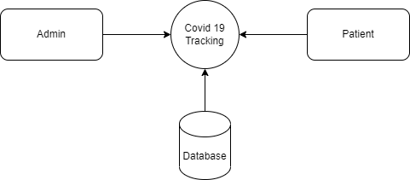

**Level 1**

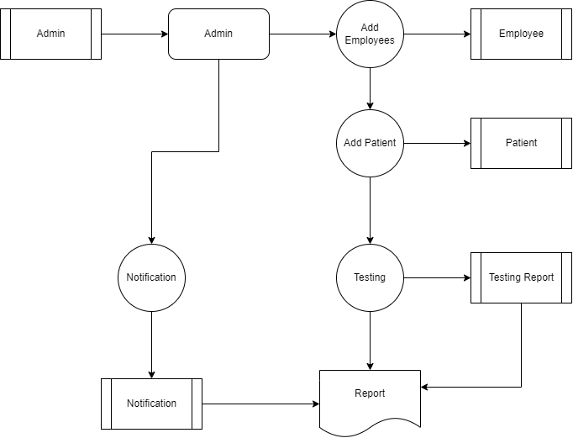

## TABLE STRUCTURE

**Table Name :** Admin

**Primary Key :** Admin_id

**Table Description :** This table is used to maintain the details about Admin

|  |  |  |  |
| --- | --- | --- | --- |
| **FIELD NAME** | **DATA TYPE** | **SIZE** | **CONSTRAINT** |
| Admin_id | Int | 8 | Primary Key |
| Admin Name | Varchar | 10 | Not null |
| Username | Varchar | 10 | Not null |
| Mobile | Int | 10 | Not null |
| Email | Varchar | 25 | Not null |
| Password | Varchar | 30 | Not null |

**Table Name :** Patient

**Primary Key :** Patient_id

**Table Description :** This table is used to maintain the details about Patient

|  |  |  |  |
| --- | --- | --- | --- |
| **FIELD NAME** | **DATA TYPE** | **SIZE** | **CONSTRAINT** |
| Patient_id | Int | 8 | Primary Key |
| Name | Varchar | 25 | Not null |
| Mobile | Varchar | 10 | Not null |
| DOB | Varchar | 10 | Not null |
| Govt Id | Varchar | 30 | Not null |
| Govt No | Int | 20 | Not null |
| Address | Varchar | 50 | Not null |
| State | Varchar | 15 | Not null |

**Table Name :** Report

**Primary Key :** Report_id

**Table Description :** This table is used to maintain the details about Report

|  |  |  |  |
| --- | --- | --- | --- |
| **FIELD NAME** | **DATA TYPE** | **SIZE** | **CONSTRAINT** |
| Report_id | Int | 8 | Primary Key |
| Order Number | Int | 10 | Not null |
| Remark | Varchar | 30 | Not null |
| Status | Varchar | 20 | Not null |

**Table Name :** Test Record

**Primary Key :** Customer_id

**Table Description :** This table is used to maintain the details about Customer

|  |  |  |  |
| --- | --- | --- | --- |
| **FIELD NAME** | **DATA TYPE** | **SIZE** | **CONSTRAINT** |
| Record_id | Int | 8 | Primary Key |
| Order Number | Int | 10 | Not null |
| Mobile Number | Int | 10 | Not null |
| Test Type | Varchar | 10 | Not null |
| Assigned Emp Id | Int | 10 | Not null |

## C. Sample Coding

<?java session_start();

//DB conncetion

include_once('includes/config.java');

//validating Session

if (strlen($_SESSION['aid']==0)) {

header('location:logout.java');

} else{

if(isset($_POST['submit'])){

//getting post values

$empid=$_POST['empid'];

$fname=$_POST['fullname'];

$mnumber=$_POST['mobilenumber'];

$query="insert into tblphlebotomist(EmpID,FullName,MobileNumber) values('$empid','$fname','$mnumber')";

$result =mysqli_query($con, $query);

if ($result) {

echo '<script>alert("Phlebotomist created successfully.")</script>';

echo "<script>window.location.href='add-phlebotomist.java'</script>";

}

else {

echo "<script>alert('Something went wrong. Please try again.');</script>";

echo "<script>window.location.href='add-phlebotomist.java'</script>";

}

}

?>

<!DOCTYPE html>

<html lang="en">

<head>

<meta charset="utf-8">

<meta http-equiv="X-UA-Compatible" content="IE=edge">

<meta name="viewport" content="width=device-width, initial-scale=1, shrink-to-fit=no">

<meta name="description" content="">

<meta name="author" content="">

<title>Covid-19 Testing Management System | Add Phlebotomist</title>

<!-- Custom fonts for this template-->

<link href="vendor/fontawesome-free/css/all.min.css" rel="stylesheet" type="text/css">

<link

href="https://fonts.googleapis.com/css?family=Nunito:200,200i,300,300i,400,400i,600,600i,700,700i,800,800i,900,900i"

rel="stylesheet">

<!-- Custom styles for this template-->

<link href="css/sb-admin-2.min.css" rel="stylesheet">

<style type="text/css">

label{

font-size:16px;

font-weight:bold;

color:#000;

}

</style>

<script>

function empidAvailability() {

$("#loaderIcon").show();

jQuery.ajax({

url: "check_availability.java",

data:'employeeid='+$("#empid").val(),

type: "POST",

success:function(data){

$("#empid-availability-status").html(data);

$("#loaderIcon").hide();

},

error:function (){}

});

}

</script>

</head>

<body id="page-top">

<!-- Page Wrapper -->

<div id="wrapper">

<?java include_once('includes/sidebar.java');?>

<!-- Content Wrapper -->

<div id="content-wrapper" class="d-flex flex-column">

<!-- Main Content -->

<div id="content">

<!-- Topbar -->

<?java include_once('includes/topbar.java');?>

<!-- End of Topbar -->

<!-- Begin Page Content -->

<div class="container-fluid">

<!-- Page Heading -->

<h1 class="h3 mb-4 text-gray-800">Add Employee</h1>

<form name="addphlebotomist" method="post">

<div class="row">

<div class="col-lg-8">

<!-- Basic Card Example -->

<div class="card shadow mb-4">

<div class="card-header py-3">

<h6 class="m-0 font-weight-bold text-primary">Personal Information</h6>

</div>

<div class="card-body">

<div class="form-group">

<label>Employee Id</label>

<input type="text" class="form-control" id="empid" name="empid" placeholder="Enter Emp Id..." required="true" onBlur="empidAvailability()">

<span id="empid-availability-status" style="font-size:12px;"></span>

</div>

<div class="form-group">

<label>Full Name</label>

<input type="text" class="form-control" id="fullname" name="fullname" placeholder="Enter your full name..." pattern="[A-Za-z ]+" title="letters only" required="true">

</div>

<div class="form-group">

<label>Mobile Number</label>

<input type="text" class="form-control" id="mobilenumber" name="mobilenumber" placeholder="Please enter your mobile number" pattern="[0-9]{10}" title="10 numeric characters only" required="true" >

</div>

<div class="form-group">

<input type="submit" class="btn btn-primary btn-user btn-block" name="submit" id="submit">

</div>

</div>

</div>

</div>

</div>

</form>

</div>

<!-- /.container-fluid -->

</div>

<!-- End of Main Content -->

<?java include_once('includes/footer.java');?>

</div>

<!-- End of Content Wrapper -->

</div>

<!-- End of Page Wrapper -->

<!-- Scroll to Top Button-->

<?java include_once('includes/footer2.java');?>

<!-- Bootstrap core JavaScript-->

<script src="vendor/jquery/jquery.min.js"></script>

<script src="vendor/bootstrap/js/bootstrap.bundle.min.js"></script>

<!-- Core plugin JavaScript-->

<script src="vendor/jquery-easing/jquery.easing.min.js"></script>

<!-- Custom scripts for all pages-->

<script src="js/sb-admin-2.min.js"></script>

</body>

</html>

<?java } ?>

<?java session_start();

//DB conncetion

include_once('includes/config.java');

//error_reporting(0);

//validating Session

if (strlen($_SESSION['aid']==0)) {

header('location:logout.java');

} else{

?>

<!DOCTYPE html>

<html lang="en">

<head>

<meta charset="utf-8">

<meta http-equiv="X-UA-Compatible" content="IE=edge">

<meta name="viewport" content="width=device-width, initial-scale=1, shrink-to-fit=no">

<meta name="description" content="">

<meta name="author" content="">

<title>Covid-Tms | All Tests</title>

<!-- Custom fonts for this template -->

<link href="vendor/fontawesome-free/css/all.min.css" rel="stylesheet" type="text/css">

<link

href="https://fonts.googleapis.com/css?family=Nunito:200,200i,300,300i,400,400i,600,600i,700,700i,800,800i,900,900i"

rel="stylesheet">

<!-- Custom styles for this template -->

<link href="css/sb-admin-2.min.css" rel="stylesheet">

<!-- Custom styles for this page -->

<link href="vendor/datatables/dataTables.bootstrap4.min.css" rel="stylesheet">

</head>

<body id="page-top">

<!-- Page Wrapper -->

<div id="wrapper">

<!-- Sidebar -->

<?java include_once('includes/sidebar.java');?>

<!-- End of Sidebar -->

<!-- Content Wrapper -->

<div id="content-wrapper" class="d-flex flex-column">

<!-- Main Content -->

<div id="content">

<!-- Topbar -->

<?java include_once('includes/topbar.java');?>

<!-- End of Topbar -->

<!-- Begin Page Content -->

<div class="container-fluid">

<!-- Page Heading -->

<h1 class="h3 mb-2 text-gray-800">All Tests</h1>

<!-- DataTales Example -->

<div class="card shadow mb-4">

<div class="card-header py-3">

<h6 class="m-0 font-weight-bold text-primary">All Tests</h6>

</div>

<div class="card-body">

<div class="table-responsive">

<form name="assignto" method="post">

<table class="table table-bordered" id="dataTable" width="100%" cellspacing="0">

<thead>

<tr>

<th>Sno.</th>

<th>Order No.</th>

<th>Patient Name</th>

<th>Mobile No.</th>

<th>Test Type</th>

<th>Time Slot</th>

<th>Reg. Date</th>

<th>Action</th>

</tr>

</thead>

<tfoot>

<tr>

<th>Sno.</th>

<th>Order No.</th>

<th>Patient Name</th>

<th>Mobile No.</th>

<th>Test Type</th>

<th>Time Slot</th>

<th>Reg. Date</th>

<th>Action</th>

</tr>

</tfoot>

<tbody>

<?java $query=mysqli_query($con,"select tbltestrecord.OrderNumber,tblpatients.FullName,tblpatients.MobileNumber,tbltestrecord.TestType,tbltestrecord.TestTimeSlot,tbltestrecord.RegistrationDate,tbltestrecord.id as testid from tbltestrecord

join tblpatients on tblpatients.MobileNumber=tbltestrecord.PatientMobileNumber

");

$cnt=1;

while($row=mysqli_fetch_array($query)){

?>

<tr>

<td><?java echo $cnt;?></td>

<td><?java echo $row['OrderNumber'];?></td>

<td><?java echo $row['FullName'];?></td>

<td><?java echo $row['MobileNumber'];?></td>

<td><?java echo $row['TestType'];?></td>

<td><?java echo $row['TestTimeSlot'];?></td>

<td><?java echo $row['RegistrationDate'];?></td>

<td>

<a href="test-details.java?tid=<?java echo $row['testid'];?>&&oid=<?java echo $row['OrderNumber'];?>" class="btn btn-info btn-sm">View Details</a>

</td>

</tr>

<?java $cnt++;} ?>

</tbody>

</table>

</form>

</div>

</div>

</div>

</div>

<!-- /.container-fluid -->

</div>

<!-- End of Main Content -->

<!-- Footer -->

<?java include_once('includes/footer.java');?>

<!-- End of Footer -->

</div>

<!-- End of Content Wrapper -->

</div>

<!-- End of Page Wrapper -->

<!-- Scroll to Top Button-->

<?java include_once('includes/footer2.java');?>

<!-- Bootstrap core JavaScript-->

<script src="vendor/jquery/jquery.min.js"></script>

<script src="vendor/bootstrap/js/bootstrap.bundle.min.js"></script>

<!-- Core plugin JavaScript-->

<script src="vendor/jquery-easing/jquery.easing.min.js"></script>

<!-- Custom scripts for all pages-->

<script src="js/sb-admin-2.min.js"></script>

<!-- Page level plugins -->

<script src="vendor/datatables/jquery.dataTables.min.js"></script>

<script src="vendor/datatables/dataTables.bootstrap4.min.js"></script>

<!-- Page level custom scripts -->

<script src="js/demo/datatables-demo.js"></script>

</body>

</html>

<?java } ?>

<?java session_start();

//DB conncetion

include_once('includes/config.java');

//error_reporting(0);

//validating Session

if (strlen($_SESSION['aid']==0)) {

header('location:logout.java');

} else{

?>

<!DOCTYPE html>

<html lang="en">

<head>

<meta charset="utf-8">

<meta http-equiv="X-UA-Compatible" content="IE=edge">

<meta name="viewport" content="width=device-width, initial-scale=1, shrink-to-fit=no">

<meta name="description" content="">

<meta name="author" content="">

<title>Covid-Tms | Assigned Tests</title>

<!-- Custom fonts for this template -->

<link href="vendor/fontawesome-free/css/all.min.css" rel="stylesheet" type="text/css">

<link

href="https://fonts.googleapis.com/css?family=Nunito:200,200i,300,300i,400,400i,600,600i,700,700i,800,800i,900,900i"

rel="stylesheet">

<!-- Custom styles for this template -->

<link href="css/sb-admin-2.min.css" rel="stylesheet">

<!-- Custom styles for this page -->

<link href="vendor/datatables/dataTables.bootstrap4.min.css" rel="stylesheet">

</head>

<body id="page-top">

<!-- Page Wrapper -->

<div id="wrapper">

<!-- Sidebar -->

<?java include_once('includes/sidebar.java');?>

<!-- End of Sidebar -->

<!-- Content Wrapper -->

<div id="content-wrapper" class="d-flex flex-column">

<!-- Main Content -->

<div id="content">

<!-- Topbar -->

<?java include_once('includes/topbar.java');?>

<!-- End of Topbar -->

<!-- Begin Page Content -->

<div class="container-fluid">

<!-- Page Heading -->

<h1 class="h3 mb-2 text-gray-800">Assigned To Phlebotomist</h1>

<!-- DataTales Example -->

<div class="card shadow mb-4">

<div class="card-header py-3">

<h6 class="m-0 font-weight-bold text-primary">Assigned Tests</h6>

</div>

<div class="card-body">

<div class="table-responsive">

<form name="assignto" method="post">

<table class="table table-bordered" id="dataTable" width="100%" cellspacing="0">

<thead>

<tr>

<th>Sno.</th>

<th>Order No.</th>

<th>Patient Name</th>

<th>Mobile No.</th>

<th>Test Type</th>

<th>Time Slot</th>

<th>Reg. Date</th>

<th>Action</th>

</tr>

</thead>

<tfoot>

<tr>

<th>Sno.</th>

## D. Sample Input

## Admin Login page

## 

## Input of login page input

## 

## Input of Add Employees

## 

## Input of patient registration

## 

## Assigned patient details

## 

## Update the status of report

## 

## E. Sample Output

**Output of Covid-19 symptoms**

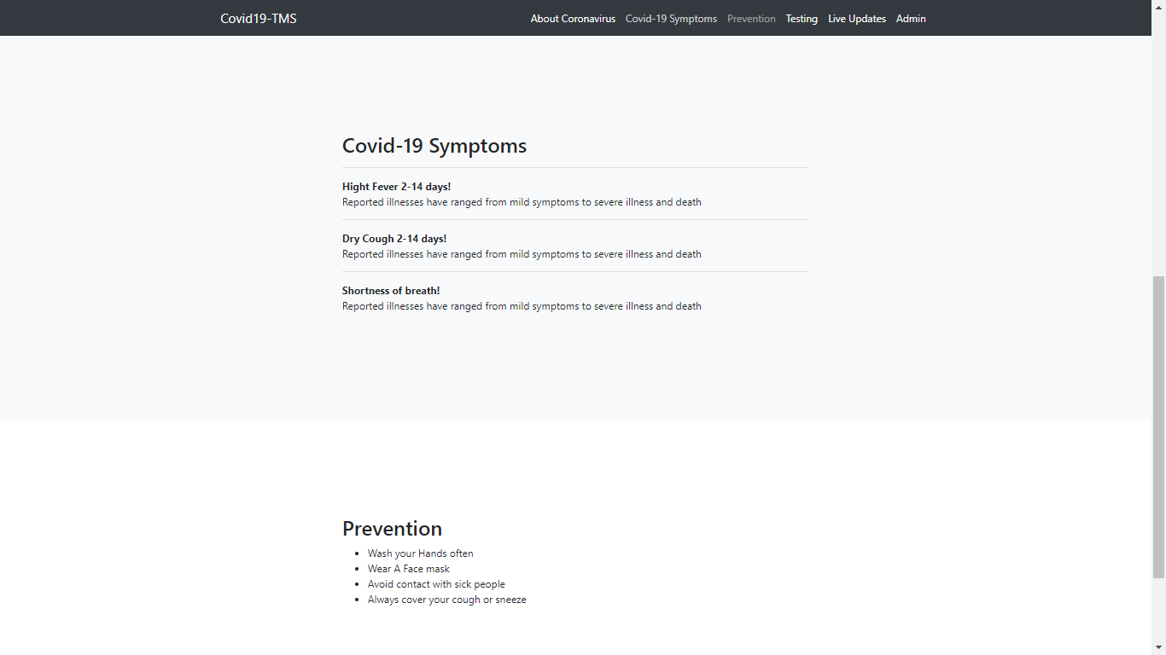

Output of invalid login credential

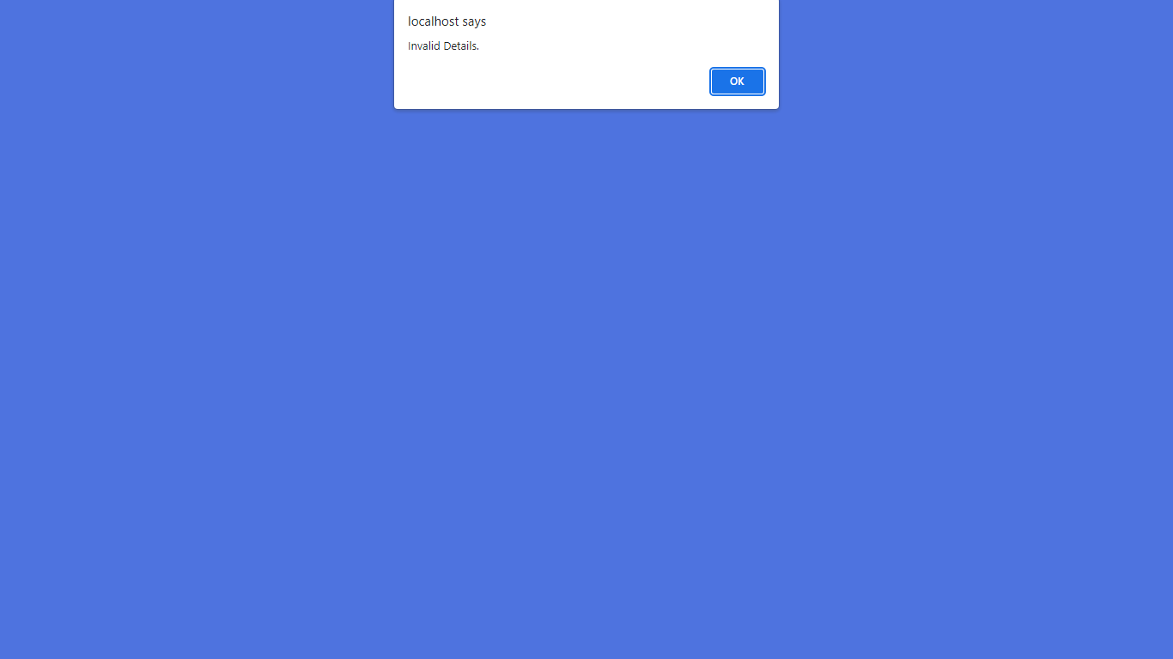

Output of dashboard screen

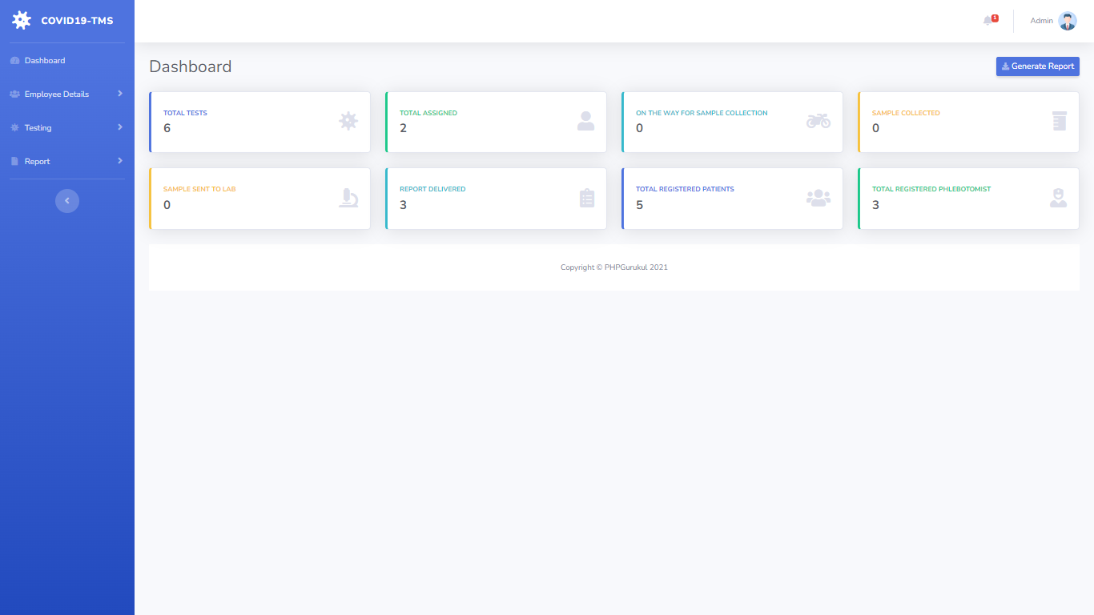

Output of employees details

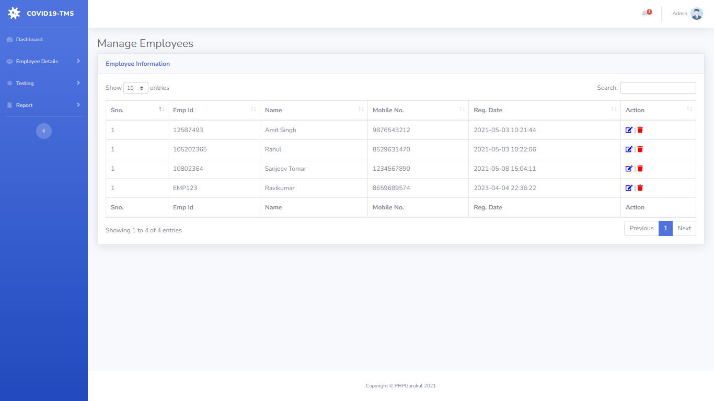

Output of user registration

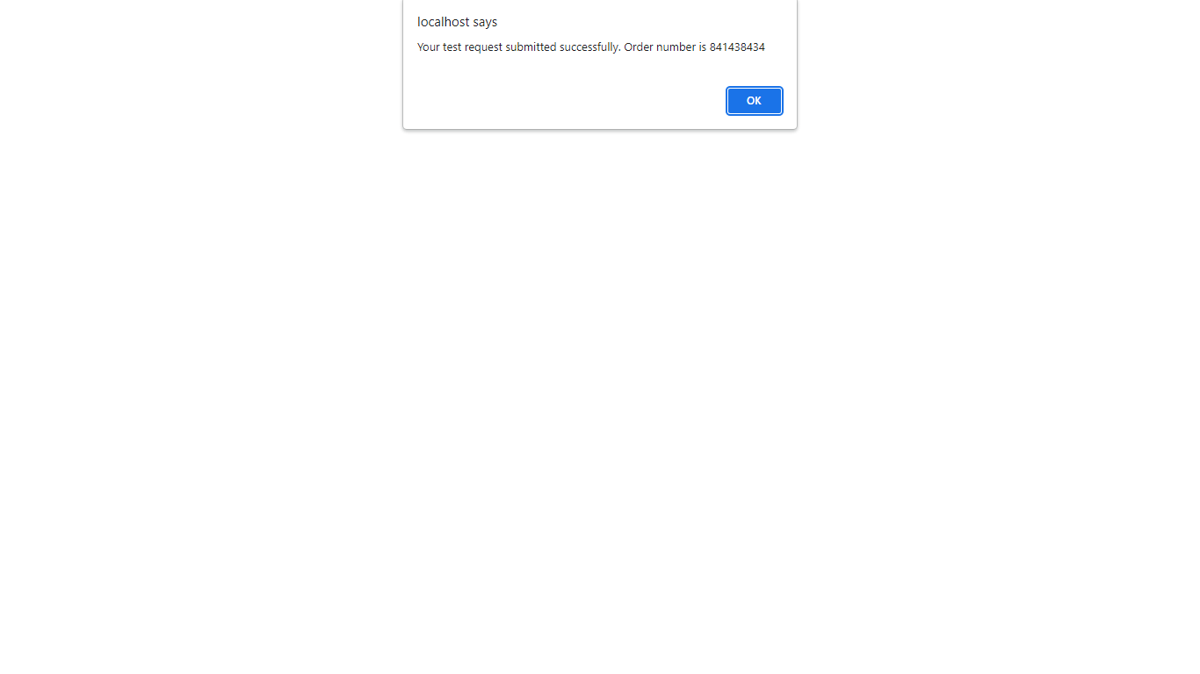

Output of search patient details

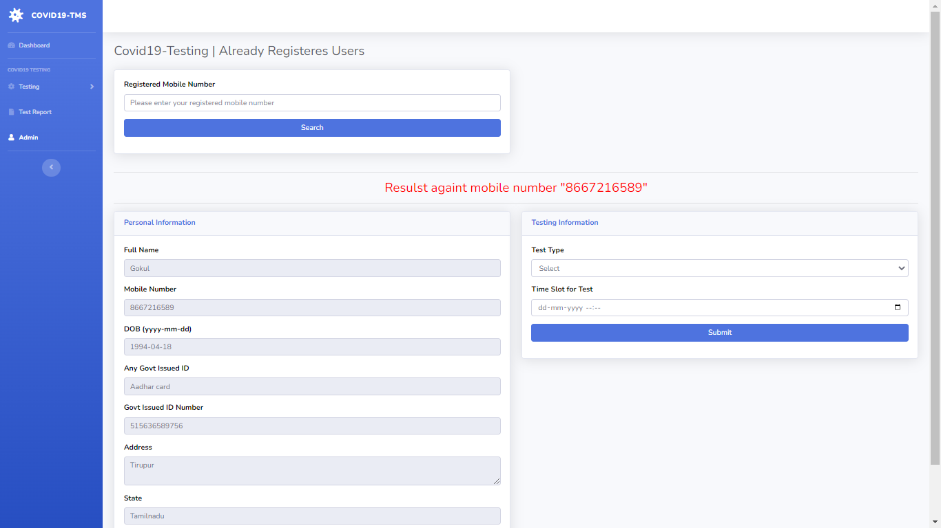

Output of patient reports

